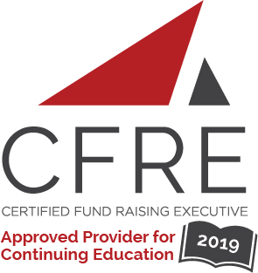  CFRE International has developed this form as a way for you to quickly track (and keep in your files!) the continuing education sessions you have attended. Simply check the boxes next to the sessions you attended. At the end of the conference, add up the total number of hours. Keep this sheet and you will be ready to complete your application form. All of the session slots listed are eligible for continuing education points on your CFRE application for initial certification and/or recertification. Sessions not listed here are not eligible for points. |  | CONTINUING EDUCATION POINTS TRACKER

Activity Organizer: - Association of Fundraising Professionals – Greater Houston Chapter
Title of Activity: - Monthly Programs
Names of Presenter(s): - Various
Dates and Location: - Houston, TX, United States

Date: 15 January, 2021
Session 1: 11:00 am– 12:00 pm (1.0 pts)
- Houston’s Economy: An Update & Outlook for 2021
Speaker(s): Gabe Roel Martinez

Date: 19 February, 2021
Session 1: 11:00 am– 12:00 pm (1.0 pts)
- Navigating Your Career Through COVID-19
Speaker(s): Stephen Newton, Rebecca Cooke, Dr. Sandy Frieden, Greg Lee, Marcus Brewer

Date: 19 March, 2021
Session 1: 11:00 am– 12:00 pm (1.0 pts)
- TBD

Date: 16 April, 2021
Session 1: 11:00 am– 12:00 pm (1.0 pts)
- TBD

Date: 21 May, 2021
Session 1: 11:00 am – 12:00 pm (1.0 pts)
- TBD

Date: 16 July, 2021
Session 1: 11:00 am – 12:00 pm (1.0 pts)
- TBD

Date: 20 August, 2021
Session 1: 11:00 am – 12:00 pm (.0 pts)
- TBD

Date: 15 October, 2021
Session 1: 11:00 am – 12:00 pm (.0 pts)
- TBD

Total number of points attained: __________

